<!DOCTYPE *html*>

<html *lang*="en">

<head>

    <title>Profile</title>

</head>

<body>

   <img  align="right" *src*="/Images/Photu.jpeg" *width*="9%">

   <h1><center>OM SINGH 's Profile</center></h1>

   <hr>

   <h2><i>General Information:-</i></h2>

       <p ><b>Name:-</b> Om Singh</p>

       <p><b>Age:-</b> 19</p>

       <p><b>Gender:-</b>Male</p>

       <p><b>Martial Status:-</b>Unmarried</p>

       <p><b>Profession:-</b>Student</p>

       <hr>

       <h3><i>What I Want To Achieve:-</i></h3>

       <p>After completing my btech degree I want to work for big MNCs companies for there Software development</p>

       <p>I want to be an actor in movie ,(will also work in this Profession also)</p>

       <hr>

       <h3>Hobby:-</h3>

       <p><i>Horse Riding</i></p>

       <p><i>Listening Musics</i></p>

       <p><i>Singing</i></p>

       <hr>

<h3>Projects that i will work/make:-</h3>

<p>Trending Web Sites(which uses reactjs,nodejs library)</p>

<p>Huffmann Encoding(A File compressor technique which uses Tree data structures)</p>

<p>Machine Learning Project related</p>

<hr>

</body>

</html>

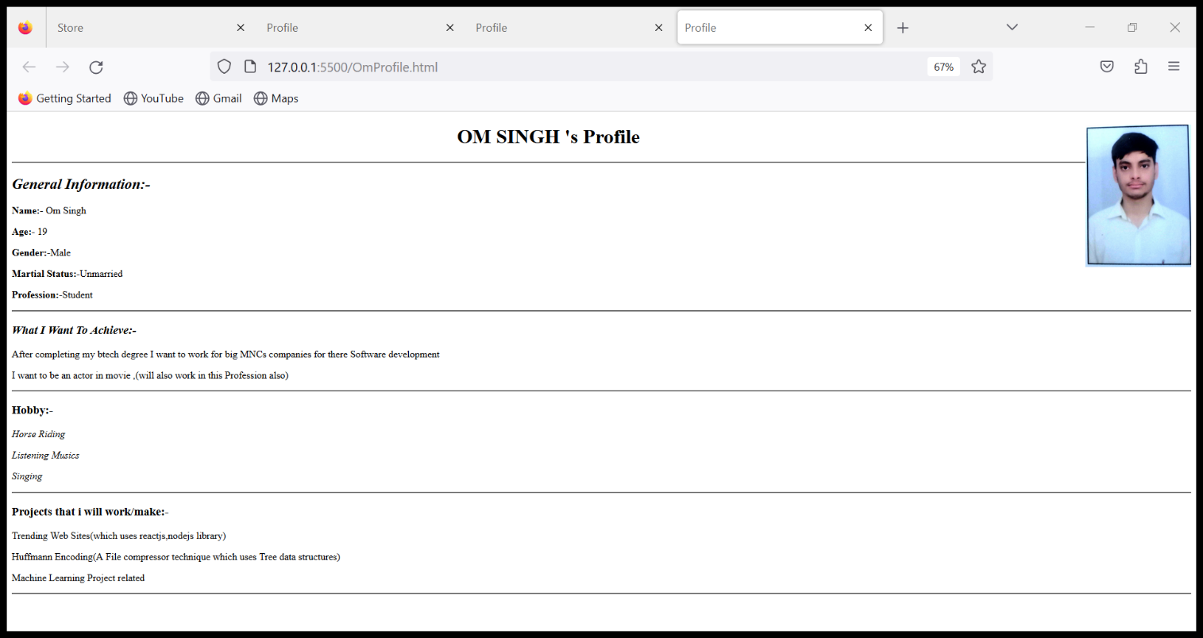

<!DOCTYPE *html*>

<html *lang*="en">

<head>

    <title>Store</title>

</head>

<body>

    <table>

        <tr>

            <td><img *width* ="35%" *height*="50%"*src*="images/lays.webp" *alt*="chips">

              <h3>Lay's Potato Chips 50g, India's Masala <br>Magic Flavour, Crunchy Chips & Snacks</h3>

               <h2>6<sup>$</sup>Only</h2>

            </td>

            <td>

                <img *src*="images/choco.webp" *width*="35%" *height*="65%">

                <h3>Cadbury Hot Chocolate Drink Powder Mix, 200 g</h3>

                <h2>60<sup>$</sup>Only</h2>

            </td>

            <td>

                <img *src*="images/cream.webp" *width*="30%" *height*="5%">

                <h3>Neutrogena Ultra sheer Sunscreen, SPF 50+<br> Ultra light, for oily and dry skin, 30ml</h3>

                <h2>600<sup>$</sup>Only</h2>

            </td>

            <td>

                <img *src*="images/drink1.webp" *width*="13%" *height*="15%">

                <h3>Sprite Lemon-Lime Flavoured Cold Drink | Refreshing Taste | Clear Soft Drink with No Added Colours <br> Recyclable PET Bottle, 2 L</h3>

                <h2>70<sup>$</sup>Only</h2>

            </td>

        </tr>

      <tr>

           <td>

            <img *src*="images/drink2.webp" *width*="65%" *height*="15%">

            <h3>Thums Up Cold Drink | Soft Drink with Strong Taste | Spicy & Fizzy Cold Drink <br>Recyclable Can, 300 ml (Pack of 6)</h3>

            <h2>120<sup>$</sup>Only</h2>

           </td>

           <td>

            <img *src*="images/exo.jpg"*width*="65%" *height*="15%">

            <h3>Exo Dish wash Round - Touch and Shine, 2 x 700g Pack</h3>

            <h2>120<sup>$</sup>Only</h2>

           </td>

           <td>

            <img *src*="images/maggi.jpg" *width*="65%" *height*="15%">

            <h3>Maggi 2-Minute Instant Noodles,<br> Masala - 70g Pouch</h3>

            <h2>12<sup>$</sup>Only</h2>

           </td>

           <td>

            <img *src*="images/pampers.jpg" *width*="45%">

            <h3>Pampers All round Protection Pants, Small size baby diapers (SM), 86 Count,<br> Anti Rash diapers, Lotion with Aloe Vera</h3>

            <h2>100<sup>$</sup>Only</h2>

           </td>

           </tr>

           <tr>

           <td>

            <img *src*="images/mos.jpg" *width*="45%">

            <h3>Good Knight Naturals, Pack Of 4 Refills Neem Mosquito Repellent With 100% Natural Active<br> Ingredients (Safe For Kids And Adults)</h3>

            <h2>140<sup>$</sup>Only</h2>

           </td>

           <td>

             <img *src*="images/shoe.webp" *width*="45%">

             <h3>Campus Men's Barley Running Shoes</h3>

             <h2>1400<sup>$</sup>Only</h2>

           </td>

           <td>

            <img *src*="images/toy.webp" *width*="45%">

            <h3>Mirana USB Rechargeable Racing RC Car with Nitro Booster <br>| High Speed Remote Control Toy Gift for Boys and Kids Girls (Dark Purple)</h3>

           <h2>1200<sup>$</sup>Only</h2>

          </td>

          <td>

            <img *src*="images/toy3.webp" *width*="45%">

            <h3>Rubela Plastic 1:18 Rechargeable 4Wd 2.4GHz Rock Crawler Off Road R/C Car <br>Monster Truck Kids Toys | Remote Control Cars for Kids- Pack of 1, Multicolor</h3>

            <h2>999<sup>$</sup>Only</h2>

          </td>

           </tr>

    </table>

</body>

</html>

